Human Evolution Intro

Evolution:

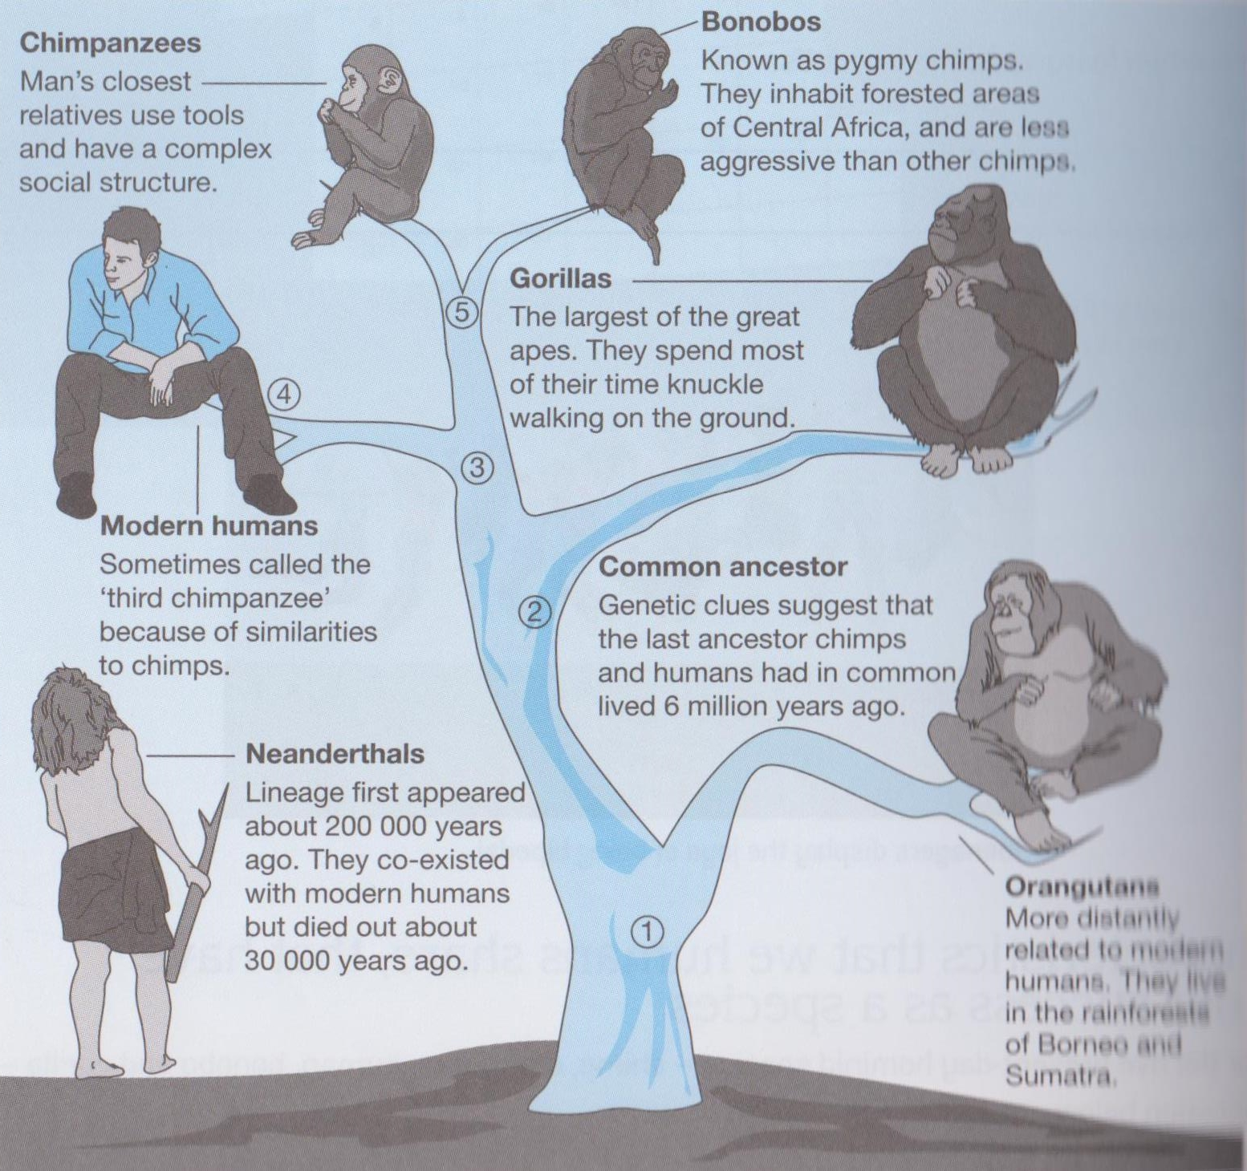
Evolution of organisms has taken place over 2.6 billion years. In this topic we will focus on hominin biological and cultural evolution (progressive change and development from our hominin ancestors to modern humans), and dispersal from Africa over the past 5-6 million years.

Humans, primates and the great apes:

- Hominins is the taxanomic group that includes modern humans (homo sapiens) and ancestral humans (Homo spp., Australopithecus spp., Ardipithecus spp.) A distinguishing feature of hominins is habitual bipedalism - the ability to stand and move on two legs for long periods of time. Bipedalsim is the normal walking habit for all hominins; in the great apes, movement is habitually quadrupedal - moving using all four limbs. Humans and the great apes belong to the hominid family within the primate order of mammals.

Using“Level 3 Biology” p.199 to assist, write a definition for the following:
Primates:
Hominid:
Hominin:

Below is a possible taxonomic tree of the hominids (Great apes - which includes humans)
Use the above image to help you complete the taxonomic tree by placing the correct picture of the 5 present-day hominid species ( chimp, orangutan, bonobo, human and gorilla) on the top line.
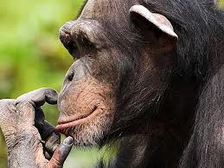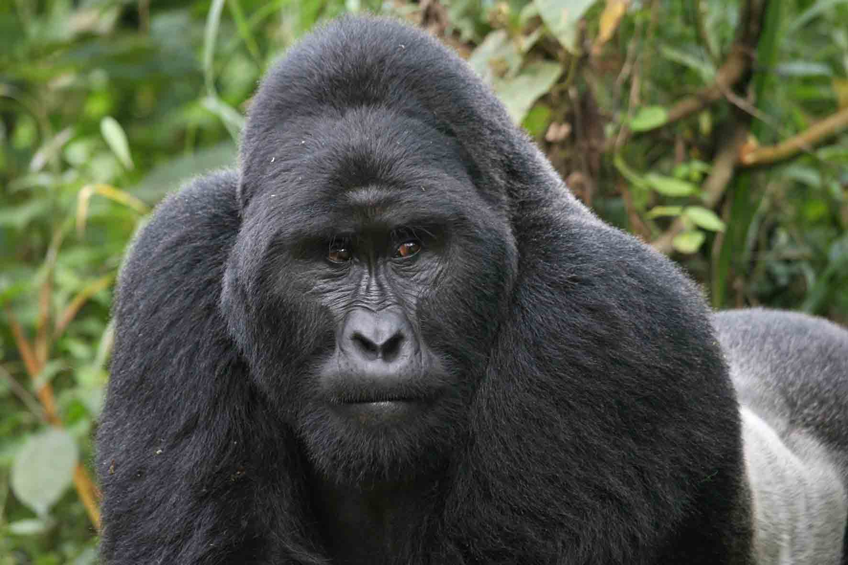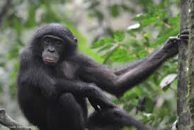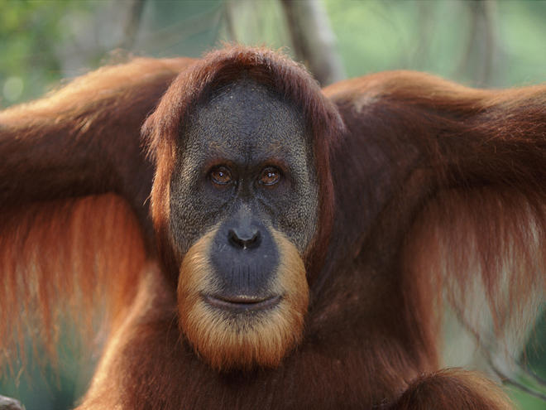
Species
Subfamily
Order
Superfamily
Family
Tribe
Panini
Pongidae
Homininae
Hominoidae
Primates
Hominininae
Hominini
Gorillini

Human

Chimp

Gorilla

Bonobo

Orangutan
Open this “Drawing application” so you can drag the pictures into the correct box
The Great Apes

The push to evolve:

- Around 5 million years ago the African climate changed. Cooler and drier climate meant areas of dense forest changed to open savaanah (grassland with scattered trees experiencing seasonally dry, hot conditions.
- The divergence of hominins from their ape-like, arboreal (living in trees) ancestors took place as major adaptations to the changing environment occurred within the hominid groups.
- It is thought bipedalism (habitually walking on two legs) evolved first, followed by changes in teeth and jaws, and finally the development of the brain which allowed for the more complex cultural evolution of humans compared to other present day apes.
- The evolution of humans has occurred through natural selection, where the best adapted individuals survived or outcompeted others for breeding partners, thus passing on their successful alleles to their offspring. Theses successful alleles then increased in frequency in the gene pool.

From your textbook “Level 3 Biology” complete activity 3.6A question 2 p.201.

Characteristics aiding our success shared with other primates:

There are some characteristic we share with other primates that have helped in our success.
Use the textbook “Continuing Life Processes” p.199-202 to help you describe why the following shared characteristics would have assisted in humans advancement.

- A forelimb that can explore

- The grasping limb (include definition of opposability)

- A generalised diet

- Large mobile lips

- Good stereoscopic vision

- Large brains

- Modified skulls

- Reduced number of offspring and increased care

There is a characteristic we perform to a much greater extent than the other primates that has set us apart from other primates and allowed us to evolve more advanced skills than other modern day apes?
ve helped in our success.
Name this main physical characteristic

